Anaplan Integration – High level working
working scripts and the data flow
1. Purpose
We built three small scripts that move data between Anaplan and our forecasting model. One script pulls data out of Anaplan, our model forecasts on it, and another script writes the results back in. This document explains how the pieces fit together.
2. The Three Files
Everything is split into three files, each with one job:
File | What it does
anaplan_client.py | It communicates to Anaplan. Handles logging in, pulling data out (export), and pushing data back in (import).
forecast_engine.py | Our forecasting model. Takes the exported data and produces a forecast. In our environment as this script Knows nothing about Anaplan.
run_integration.py | Ties everything together. Runs the four steps in order with one command.
3. How the Files Connect
run_integration.py is the one you actually run. It calls the other two files in turn — first anaplan_client.py to get data out of Anaplan, then forecast_engine.py to forecast on it, then anaplan_client.py again to send the result back:
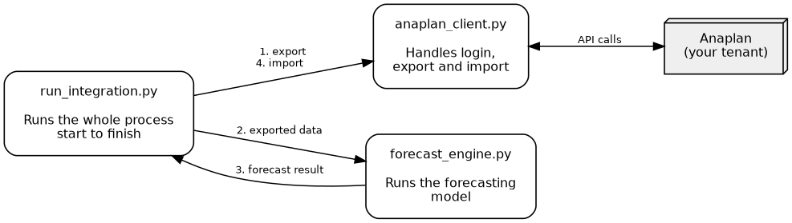
anaplan_client.py is the only file that communicate to Anaplan directly.
4. The Four-Step Flow
Every run follows the same four steps, in the same order:
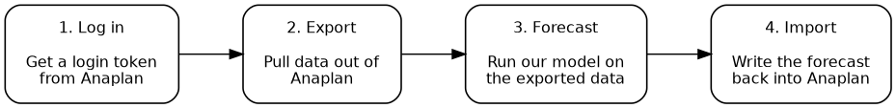
The four steps run_integration.py performs, start to finish.
- Log in — gets permission from Anaplan to make the calls below.
- Export — pulls the data we need out of a chosen Anaplan view.
- Forecast — our model runs on that data. This step never talks to Anaplan.
- Import — sends the forecast back into Anaplan, into the module planners use.
5. Running It
One command runs all four steps:
python run_integration.py \
--email you@company.com --password ***** \
--workspace-id <workspace id> --model-id <model id> \
--export-id <export id> --export-file-id <file id> \
--import-id <import id> --import-file-id <file id>

It prints each step as it happens — rows exported, forecast rows produced, import result — so it’s easy to see where it is or where it stopped.
6. What’s Needed Before Running It
- An Anaplan login (username and password, or a certificate for automated runs).
- The workspace ID and model ID for the tenant we’re connecting to.
- The export ID and file ID for the view we’re pulling data from.
- The import ID and file ID for the module we’re writing the forecast into.
These IDs come from Anaplan itself - an admin can provide them, or they can be looked up with a short discovery call once we have login access.

